**NFT Based Crypto Analysis**

**(Using Machine Learning)**

**MINOR PROJECT**

**(20SSP38)**

Submitted by

**SANJAY K**

**(20MSS040)**

Under the Guidance of

**Prof. C. Deepa, MSc. MPhil. MBA., MA (Yoga),**

AssistantProfessor

Department of Software Systems

In partial fulfillment of the requirements for the award of the degree of

**MASTER OF SCIENCE IN SOFTWARE SYSTEMS**

(Five-years integrated course)

Of Bharathiar University

 

**DEPARTMENT OF SOFTWARE SYSTEMS**

**PSG COLLEGE OF ARTS & SCIENCE**

An Autonomous college - Affiliated to Bharathiar University

Accredited with ‘A++’grade by NAAC (4th Cycle)

College with Potential for Excellence

(Status Awarded by the UGC)

Star College Status Awarded by DBT - MST

An ISO 9001:2015 Certified Institution

Coimbatore - 641 014

**December 2022**

**DEPARTMENT OF SOFTWARE SYSTEMS**

**PSG COLLEGE OF ARTS & SCIENCE**

An Autonomous college - Affiliated to Bharathiar University

Accredited with ‘A++’grade by NAAC (4th Cycle)

College with Potential for Excellence

(Status Awarded by the UGC)

Star College Status Awarded by DBT - MST

An ISO 9001:2015 Certified Institution

Coimbatore - 641 014

**CERTIFICATE**

This is to certify that this project work entitled **“NFT BASED CRYPTO ANALYSIS”** is a bonafide record of work done by **SANJAY K (20MSS040)** in partial fulfillment of the requirements for the award of Degree of **Master of Science in Software Systems** (Five years Integrated Course) of Bharathiar University.

Faculty Guide Head of the Department

###### Submitted for Viva-Voce Examination held on 01-12-2022

Internal Examiner External Examiner

**DECLARATION**

I, **SANJAY K (20MSS040)**, hereby declare that this project work entitled **“NFT BASED CRYPTO ANALYSIS”** is submitted to PSG College of Arts &Science, Coimbatore in partial fulfillment of the requirements for the award of the degree of Master of Science in Software Systems, is a record of original work done by me under the supervision and guidance of **Prof . C. Deepa, MSc. MPhil. MBA., MA (Yoga).,** AssistantProfessor, Department of Software Systems, PSG College of Arts &Science, Coimbatore.

This report has not been submitted by me for the award of any other Degree/ Diploma/ Associate ship/ Fellowship or any other similar degree to any other university.

**Place:** Coimbatore **SANJAY K**

**Date:** 01.12.2022 **20MSS040**

**ACKNOWLEDGEMENT**

My venture stands imperfect without dedicating my gratitude to a few people who have contributed a lot towards the victorious completion for my project work.

I would like to thank **Thiru L. Gopalakrishnan, Managing Trustee, PSG & Sons Charities**, for providing me prospect and surroundings that made the work possible.

I take this opportunity to express my deep sense of gratitude to **Dr. T. Kannaian, M.tech., PhD., Secretary** of PSG College of Arts &Science, Coimbatore for permitting and doing the needful towards the successful completion of this project.

I express my deep sense of gratitude and sincere thanks to our Principal **Dr. D. Brindha M.Sc., M.Phil., Ph.D.**, **MA (Yoga).,** for her valuable advice and concern on students.

I am very thankful to **Dr. A Anguraj, M.Sc., M.Phil., Ph.D**., Vice Principal (Academics), **Dr.Jayanthi M M.Com., MBA. M.Phil., Ph.D.,** Vice Principal (Student Affairs), Dr**. M Umarani, MBA, M.Phil., Ph.D.**, **Faculty-In-Charge (Student Affairs)**, for their support towards my project.

I sincerely thank **Dr. K.V. Rukmani., MCA., M.E., Ph.D.,** Head of the Department, and Department of Software Systems for his whole hearted help to complete this project successfully by giving valuable suggestions.

I convey my heartiest and passionate sense of thankfulness to my project guide **Prof. C. Deepa MSC, MPhil, MBA, MA(Yoga)** Assistant Professor, **Department of Software Systems**, for her timely suggestion which had enable me in completing the project successfully.

This note of acknowledgement will be incomplete without paying my heartful devotion to my parents, my friends and other people, for their blessings, encouragement, financial support and the patience, without which it would have been impossible for me to complete the job.

**SYNOPSIS**

As there is an increased use of crypto in the recent years, people started to adapt the use for crypto. This increased use in the market has made crypto highly volatile. This project might help small scale data analyst and large scale data analyst to predict the price of crypto that may result in increased value in the future

With the evolution of the information industry and extensive research in the field of AI in the past two decades, businesses have started to explore the ways to automate various activities using state of the art Machine Learning algorithms and Deep Neural Networks. Many IT giants and start-ups have already taken a big leap in this field and have dedicated teams and resources for research and development of cutting edge AI applications.

Online retail platforms today are extensively driven by AI-powered algorithms and applications. Activities ranging from inventory management and quality checking at the warehouse to product recommendation and sales demographics on the project, all employ machine learning at various scales.

The objective of this project is to predict the change in price of the crypto currency and to display in the user interface so that the data analyst as well as normal users can make use of the data to buy and invest or to make business decisions in crypto tokens such as Dogecoin, Ape coin, Solana etc….

Here we use AutoTS (Automatic time series) machine learning algorithm to predict the change in prices. The AutoTS python library separates the data into training and testing automatically and the output values are stored in model_results variable which can be accessed by the data analyst to make business decisions

AutoTS is a very powerful automated machine learning algorithm which is used to predict values with higher accuracy from time to time. The previous prices of Dogecoin is important because it is crucial to predict the future price of Dogecoin. This project mainly focus on helping the data analyst and business people to make business decisions.

**TABLE OF CONTENTS**

|  |  |  |
| --- | --- | --- |
| **S No** | **CONTENTS** | **PAGE NO** |
| **1** | **INTRODUCTION** |  |
|  | 1.1 Project Overview | 7 |
|  | 1.2 Module Description | 8 |
|  | 1.3 Module Description | 8 |
| **2** | **SYSTEM ANALYSIS** |  |
|  | 2.1 Existing System | 9 |
|  | 2.2 Proposed System | 9 |
| **3** | **SYSTEM CONFIGURATION** |  |
|  | 3.1 Hardware Specification | 10 |
|  | 3.2 Software Specification | 10 |
| **4** | **SOFTWARE DESCRIPTION** |  |
|  | 4.2 Terminal | 11 |
|  | 4.3 Machine Learning | 13 |
| **5** | **SYSTEM DESIGN** |  |
|  | 5.1 System Flow Diagram | 14 |
|  | 5.4 Input Design | 16 |
|  | 5.5 Output Design | 17 |
| **6** | **SYSTEM IMPLEMENTATION** | 18 |
|  | **SOFTWARE TESTING** | 19 |
| **7** | **CONCLUSION** | 21 |
| **8** | **SCOPE FOR FUTURE ENHANCEMENT** | 22 |
| **9** | **BIBLIOGRAPHY** | 23 |
| **10** | **APPENDIX** | 24 |
| **A** | Sample Coding | 24 |
| **B** | Screenshots | 26 |
|  |  |  |

1. **INTRODUCTION**
   1. **PROJECT OVERVIEW**

In this project we attempt to implement ml approach to predict NFT based crypto (Dogecoin).The objective is to predict the Dogecoin price in order to make more informed and accurate investment decision.

AutoTS is a very powerful automated machine learning algorithm which is used to predict values with higher accuracy from time to time. The previous prices of Dogecoin is important because it is crucial to predict the future price of Dogecoin. This project mainly focus on helping the data analyst and business people to make business decisions.

Initially this project displays the price prediction values of Dogecoin which was made with the inspiration of a very famous NFT (Non Fungible Token) known as Shiba Inu which represents a particular breed of dog. Crypto currency is a type of digital currency similar to dollars, euros, and yen.

The difference is that instead of the backing of a nation or federal bank, it uses an online ledger with strong cryptography to secure online transactions. Through crypto currency exchanges, one can buy and sell crypto currencies. It can also be “mined.” The popularity of crypto currencies skyrocketed in 2017 as a result of several months of exponential growth in their market capitalization. Using machine learning, this program helps in forecasting crypto currency prices. This system is adequate to aid in price prediction, and the results obtained from predicting prices using machine learning achieve accuracy under all circumstances of technical trade indication, lowering its price prediction during evaluation.

## **MODULE DESCRIPTION:**

Modules are the building blocks of a software project. The modules are separate part of a program which has many functions which are used all over the project. The modules work together to run a software. The modules make the programmer to write less code for a reputative function and updates can be added easily since the modules are separate part of a program.

This project consists of several modules. They are:

**USER**

In user module any user can access the project. It consists of a homepage where the users can access the predicted values using AutoTS machine learning python package

**COLLECTION OF DATA**

In this module, we will be collecting dataset from various platforms like kaggle.com, data.world, lionbridge.ai etc. and merging the small datasets to create one large dataset

**PREPROCESSING**

In this module, the dataset are cleaned and reduced in size by deleting the values that are not required for our machine learning model and the values with NULL and NaN (Not a Number) values are ignored so that the machine learning model can run without errors

**SPLITTING DATASET INTO TRAINING AND TESTING**

In this module, the dataset is divided into training dataset and testing dataset. The training and testing dataset are splitted automatically by AutoTS machine learning algorithm

# **SYSTEM ANALYSIS**

System analysis is conducted for the purpose of studying or its part in order to identify it objectives. It is a problem solving technique that improves the system and ensures that all the components of the system would work efficiently to accomplish their purpose.

* 1. **EXISTING SYSTEM:**

The current feedback system only is used to gather all the inputs from the user and provide separate view of every individual’s data. It does not depict the true sentiment of the students and does not classify their emotions. The current systems just act as an interface to store all the inputs from the user to a database.

## The existing system uses machine learning models which produces less accuracy

## The existing system cannot deal with NaN values or it should be cleared manually.

## It takes more time to process the output

## **PROPOSED SYSTEM:**

In the proposed system the interface is built separately for the students, teachers and the head of department. Unlike the other system, the students’ descriptive feedbacks are converted into pictorial representations for each module. Also, a line chart is issued in order to track the progress of the users in the system. All the gathered feedbacks are stored in comma separated values which is only visible only to the heads of the department.

* The working of the model is done by autoTS which deals with the NaN values easily
* It produces better accuracy than other models
* The autoTS machine learning algorithm takes less time to process the output.
* It supports multivariate outputs

# **3. SYSTEM CONFIGURATION**

A System Requirements Specification (SRS) (also known as a Software Requirements Specification) is a document or set of documentation that describes the features and behavior of a system or software application.

## **3.1. HARDWARE SPECIFICATIONS**

|  |  |
| --- | --- |
| **Component** | **Minimum Requirement** |
| PROCESSOR | 1.6GHz or faster processor |
| MOTHERBOARD | Intel 915GV chipset board |
| RAM | 4 GB |
| DISK SPACE | 512 GB |
| KEYBOARD | 104 Keys Standard |
| MOUSE | Optical Mouse |
| MONITOR | Coloured Monitor |

**3.2. SOFTWARE SPECIFICATIONS**

|  |  |
| --- | --- |
| **Component** | **Minimum Requirement** |
| OPERATING SYSTEM | Windows 7 or Above |
| DEVELOPMENT TOOL | VS Code Editor |
| WEB BROWSER | Google Chrome |
| FRONT END | HTML 5, CSS 3 |
| FRAMEWORK | Flask |
| BACK END | Python |

**SOFTWARE DESCRIPTION**

###### TERMINAL

**4.2 PYTHON**

Python is a high-level, general-purpose programming language. Its design philosophy emphasizes code readability with the use of significant indentation.

Python is dynamically-typed and garbage-collected. It supports multiple programming paradigms, including structured (particularly procedural), object-oriented and functional programming. It is often described as a "batteries included" language due to its comprehensive standard library.

###### FEATURES OF PYTHON:

###### 1. FREE AND OPEN SOURCE:

###### Python language is freely available at the official project and you can download it from the given download link below click on the Download Python keyword. Download Python Since it is open-source, this means that source code is also available to the public. So you can download it, use it as well as share it.

###### 2. EASY TO CODE:

###### Python is a high-level programming language. Python is very easy to learn the language as compared to other languages like C, C#, JavaScript, Java, etc. It is very easy to code in the Python language and anybody can learn Python basics in a few hours or days. It is also a developer-friendly language.

###### 3. EASY TO READ:

###### As you will see, learning Python is quite simple. As was already established, Python’s syntax is really straightforward. The code block is defined by the indentations rather than by semicolons or brackets

###### 4. OBJECT ORIENTED LANGUAGE:

###### One of the key features of Python is Object-Oriented programming. Python supports object-oriented language and concepts of classes, object encapsulation, etc.

###### 5. GUI PROGRAMMING SUPPORT:

###### Graphical User interfaces can be made using a module such as PyQt5, PyQt4, wxPython, or Tk in python. PyQt5 is the most popular option for creating graphical apps with Python.

###### 6. HIGH LEVEL LANGUAGE:

###### Python is a high-level language. When we write programs in Python, we do not need to remember the system architecture, nor do we need to manage the memory.

###### 7. EXTENSIBLE FEATURE:

###### Python is an Extensible language. We can write some Python code into C or C++ language and also we can compile that code in C/C++ language.

###### 8. EASY TO DEBUG:

###### Excellent information for mistake tracing. You will be able to quickly identify and correct the majority of your program’s issues once you understand how to interpret Python’s error traces. Simply by glancing at the code, you can determine what it is designed to perform.

###### 9. PYTHON IS A PORTABLE LANGUAGE:

###### Python language is also a portable language. For example, if we have Python code for windows and if we want to run this code on other platforms such as Linux, UNIX, and Mac then we do not need to change it, we can run this code on any platform.

###### 10. PYTHON IS A INTEGRATED LANGUAGE:

###### Python is also an integrated language because we can easily integrate Python with other languages like C, C++, etc.

###### 11. INTERPRETED LANGUAGE:

###### Python is an Interpreted Language because Python code is executed line by line at a time. Like other languages C, C++, Java, etc. there is no need to compile Python code this makes it easier to debug our code. The source code of Python is converted into an immediate form called byte code.

###### 12. LARGE STANDARD LIBRARY:

###### Python has a large standard library that provides a rich set of modules and functions so you do not have to write your own code for every single thing. There are many libraries present in Python such as regular expressions, unit-testing, web browsers, etc.

###### 13. DYNAMICALLY TYPED LANGUAGE:

###### Python is a dynamically-typed language. That means the type (for example- int, double, .) for a variable is decided at run time not in advance because of this feature we don’t need to specify the type of variable.

###### 14. FRONTEND AND BACKEND DEVELOPMENT:

###### With a new project py script, you can run and write Python codes in HTML with the help of some simple tags <py-script>, <py-env>, etc. This will help you do frontend development work in Python like JavaScript. Backend is the strong forte of Python it’s extensively used for this work cause of its frameworks like Django and Flask.

**MACHINE LEARNING:**

###### Machine learning is a branch of artificial intelligence (AI) and computer science which focuses on the use of data and algorithms to imitate the way that humans learn, gradually improving its accuracy.

Machine learning is an important component of the growing field of data science. Through the use of statistical methods, algorithms are trained to make classifications or predictions, and to uncover key insights in data mining projects. These insights subsequently drive decision making within applications and businesses, ideally impacting key growth metrics. As big data continues to expand and grow, the market demand for data scientists will increase. They will be required to help identify the most relevant business questions and the data to answer them. Machine learning algorithms are typically created using frameworks that accelerate solution development, such as Tensor Flow and PyTorch.

# **SYSTEM DESIGN**

## **SYSTEM FLOW DIAGRAM**

A system flowchart shows the path taken by data in a system and the decisions made during different levels. Different symbols are strung together to show data flow, including what happens to data and where it goes. To show the scope and boundaries of a system.

A system flowchart is mainly used for physical modelling of the system showing inputs, outputs, and processes. Analysts frequently use them to illustrate the whole system graphically. There are multiple symbols used in a system flowchart. All symbols are unique and represent a different process, input, output, or media item. A system flowchart begins and ends with an oval symbol. This is also called the ‘terminator’ and indicates the start and end of the processes mentioned.

A rectangle then represents a process or an activity.

If any data is input into the computer, then a parallelogram is used. The data input can be in many forms, including keyboard, microphone, mouse, scanner, and multiple other kinds of sensors.

Then there are multiple types of output like printers, display devices, or speakers.

One of the major symbols used in system flowcharts is the decision boxes represented by a diamond shape. They represent the decisions made, and all arrows coming out of these decision boxes show alternate pathways for data.

Lastly, all these shapes are connected through arrows showing the direction of the flow and how data moves along the entire system.

However, just knowing the flowchart symbols is simply not enough for understanding a system flowchart. To understand it, you need to trace the pathway from one symbol to another. If you land on a decision symbol showing two alternate paths, you need to trace both of them to see where they end.

**Figure:** System flow Diagram

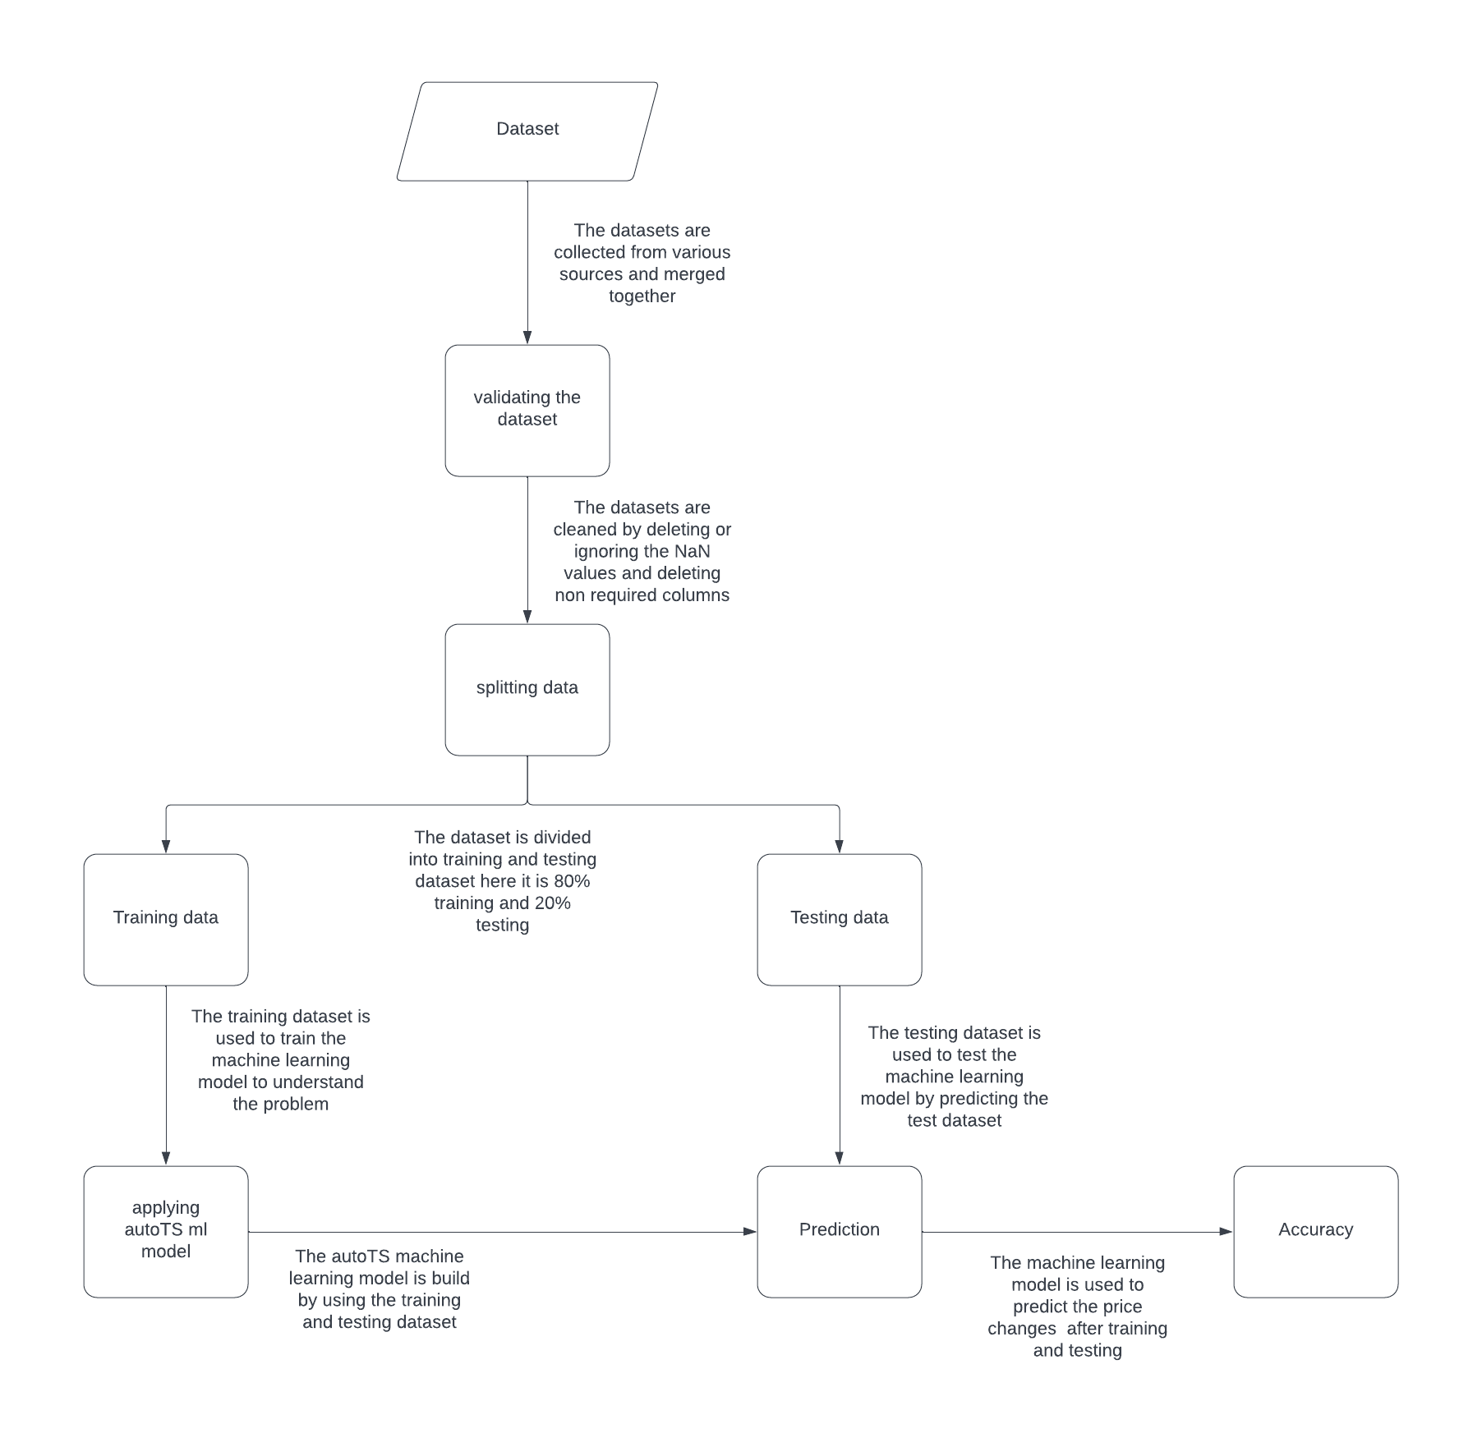

**5.2 INPUT DESIGN:**

Input design is the part of overall system design which requires very careful attention. Often the collection of input data is the most expensive part of the system, in terms of both the equipment used and the number of people involved; it is the point of most contact for the users with the computer system; and it is prone to error. If data going into the system are incorrect, then the processing and output will magnify these errors. In this system inputs are given in two ways, one by the customer as their details are collected in such a way that admin can access, and another input is from the registering them

**Figure:** Input Design

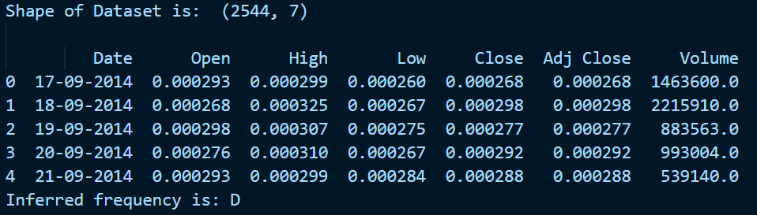

**Description**: Inputs present in the dataset

**5.3. OUTPUT DESIGN:**

Output design plays a very important role in a system. Getting a correct output is a task that has to be concentrated, as a system is validated as a correct one only if it gives the correct output according to the input. Here in this work the toast messages play a vital role in redirecting the user. It displays the messages and updates the user of what is happening in the application. It shows an error message and also the successful message of responding to the user.

**Figure:** Output Design

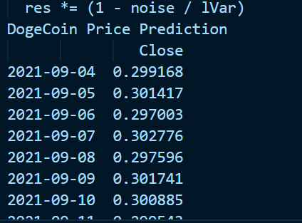

**Description**: Outputs obtained from model

1. **SYSTEM IMPLEMENTATION AND TESTING**
   1. **SYSTEM IMPLEMENTATION**

Implementation is the stage of the project when the theoretical design is turned into a working system. The implementation stage is a system project in its own right. It includes careful planning, investigation of the current system and its constraints on implementation, design of methods to achieve the changeover, training of the staff in the changeover procedure and evaluation of the changeover method. The first task in implementation is planning and deciding on the methods and time scale to be adopted. Once the planning has been completed the major effort is to ensure that the programs in the system are working properly when the staff has been trained, the complete system involving both computer and user can be executed effectively. Thus, clear plans are prepared for the activities. Successful implementation of the new system design is a critical phase in the system life cycle. Implementation means the process of converting a new or a revised system design into an operational one.

Software implementation is the process of adopting and integrating a software application into your company’s systems and workflows. It can apply to software as simple as project management software like Asana or software needed for critical business operations like enterprise resource planning (ERP) or supply chain software. The implementation process can also apply to software updates or significant upgrades that require development work.

Implementation can be a daunting task, but it also has the potential to make your company more productive and profitable. It’s worth taking on the challenge since you could end up being much better off in just one year than you would have been if you hadn’t made any changes. Shortcutting the planning stages can send negative ripples through your entire organization — at best, a rushed implementation will slow everyone down and cause headaches. At worst, shortcuts could contribute to your company’s downfall.

Poor implementation can cause unexpected downtime that costs you extra money in lost revenue and salaries paid out for little to no productivity. For example, if your employees can’t figure out how to use your new software because of a poor configuration or integration, they could develop workarounds that are less accurate or efficient.

**6.2 SOFTWARE TESTING**

This content gives the outline of all testing methods that are carried out to get a bug free system. Quality can be achieved by testing the product using different techniques at different phases of the project development. The purpose of testing is to discover errors. Testing is the process of trying to discover every conceivable fault or weakness in a work product. It provides a way to check the functionality of components subassemblies and/or a finished product. It is the process of exercising software with the intent of ensuring that the Software system meets its requirements and user expectations and does not fail in an unacceptable manner. There are various types of test. Each test type addresses a specific testing requirement. 23 TESTING OBJECTIVES The main objectives of testing process are as follows

* Testing is a process of executing a program with the intent of finding an error.
* A good test case is one that has high probability of finding undiscovered error.
* A successful test is one that uncovers the undiscovered error. TESTING PRINCIPLES
* All tests should be traceable to customer requirements.
* Tests should be planned large before testing begins.
* Testing should begin “In the Small” and progress towards “In the Large”. TYPES OF TESTING In order to make sure that the system does not have errors, the different levels of testing strategies that are applied at differing phases of software development are:

**UNIT TESTING:**

Unit Testing is done on individual modules as they are completed and become executable. It is confined only to the designer's requirements. Each module can be tested using the following two strategies:

**BLACK BOX TESTING:**

* In this strategy some test cases are generated as input conditions that fully execute all functional requirements for the program. Only the output is checked for correctness. The logical flow of data is not checked. This testing has been uses to find errors in the following categories: Incorrect or missing functions
* Interface errors
* Errors in data structure or external database access
* Performance errors
* Initialization and termination error.

**WHITE BOX TESTING:**

* In this the test cases are generated on the logic of each module by drawing flow graphs of that module and logical decisions are tested on all the cases. It has been uses to generate the test cases in the following cases:
* Guarantee that all independent paths have been executed.
* Execute all logical decisions on their true and false sides.
* Execute all loops at their boundaries and within their operational bounds.
* Execute internal data structures to ensure they are valid

**INTEGRATION TESTING:**

Integration testing ensures that software and subsystems work together as a whole. It tests the interface of all the modules to make sure that the modules behave properly when integrated together. System Testing Involves in-house testing of the entire system before delivery to the user. Its aim is to satisfy the user that the system meets all requirements of the client's specifications. Acceptance Testing It is a pre-delivery testing in which the entire system is tested at the client's site on real world data to find errors.

1. **CONCLUSION**

It is concluded that the NFT based Crypto Analysis works well and satisfy the users in viewing prices predicted by the machine learning model. This project is developed using HTML, CSS, Python, Flask and Machine Learning. The user interface of the project is simple and easily understandable.

The project work well in both mobile device and desktop devices to have better user experience. The framework gives many price information’s to the data analysts and investors. This portal will serve the cause of knowledge gathering for all the data analysts as well as the investors. All required testing is done to make the user have better experience using this framework. The project helps the data analyst and the investors in all possible ways to grew better by following the results provided by the project. In this model, it helps to analyze the growth of the companies from different sectors and try to find out which is the best time span for the best value to buy crypto currency.

So, this draws an important conclusion that companies from a certain sector have the same dependencies as well as the same growth rate. The prediction can be more accurate if the model is trained with a greater number of datasets. This framework broadly helps in market analysis and prediction of growth of Dogecoin in different time spans.

The first part of my analysis focuses on evaluation of Dogecoin based on qualitative data. It is more about understanding the background, team, product, and vision of a project. Use the questions presented to dig deeper into the real value of this project.

I can’t promise you that everyone of your moves in this market will be successful, only because you copy these steps but take this model as a guide or map to find your own way of researching crypto, and if you do so on a constant basis and with a lot of effort and discipline, I promise you, the number of successful investment will increase.

1. **SCOPE FOR FUTURE ENHANCEMENT**

The project has covered almost all the requirements. Further requirements and improvements can easily be done since the coding is mainly structured or modular in nature. Improvements can be appended by changing the existing modules or configuring the existing modules.

The purpose of this project is to predict the price of the Crypto currency or token based on the dataset provided by various resources such as kaggle, lionsdataset etc. Here we take a medium sized dataset for prediction and analysis. In future we may collect a better dataset or create a better dataset and we will predict the patterns and price with the help of other new machine learning algorithms.

The user interface of the project can be improved for better user interaction and easy understandability. This project can offer other big crypto predictions such as Etherium, Bitcoin, and BNB etc. The functionality of the project can be improved so that the users can access the project easily. Using more granular data such as data of every day, every minute, and every second can improve accuracy of prediction as it contains more insightful information than one day data.

Future work contains providing predictions and recommendations for individuals according to their risk and reward appetite, and also providing a portfolio management to mitigate the risk associated with investing in stock market.

The Algorithm used in this project can be optimized by configuring the algorithm to run at very low time than the existing algorithm and the space used by algorithm can be minimized by efficiently running the machine learning model.

Multiple inputs can be introduced to predict the prices with particular parameters and the previous data can be stored in the database for future references and predictions. The functionality in the machine learning model can be improved.

**9. BIBLIOGRAPHY**

**REFERENCE BOOKS:**

1. HTML and CSS: Visual QuickStart Guide - 8th Edition, Elizabeth Castro, Bruce Hyslop
2. Learning Web Design - 4th Edition, Jennifer Niederst Robbins
3. A Byte of Python – by Swaroop C H
4. Python Machine Learning – By Ryan Turner

**PROJECT REFERENCES:**

[http://www.stackflow.com/](http://stackflow.com/)

<http://www.w3schools.com/>

http://www.python.org/

http://www.machinelearningmastery.com/

**10. APPENDIX**

1. **Sample code**

#importing required libraries

import numpy as np

import pandas as pd

import matplotlib.pyplot as plt

import seaborn as sns

from seaborn import regression

from autots import AutoTS

import pickle

#setting plotting style

sns.set()

plt.style.use('seaborn-whitegrid')

#validating data

data = pd.read_csv("Dogecoin.csv")

print("Shape of Dataset is: ",data.shape,"\n")

print(data.head())

#visualizing data in plot view

data.dropna()

plt.figure(figsize=(10, 4))

plt.title("DogeCoin Price INR")

plt.xlabel("Date")

plt.ylabel("Close")

plt.plot(data["Close"])

plt.show()

#applying ml model

model = AutoTS(forecast_length=10, frequency='infer', ensemble='simple', drop_data_older_than_periods=200)

model = model.fit(data, date_col='Date', value_col='Close', id_col=None)

#predicting the values

prediction = model.predict()

#printing the tested values

forecast = prediction.forecast

print("DogeCoin Price Prediction")

print(forecast)

model_results=model.results()

pickle.dump(forecast,open('model.pkl','wb'))

model=pickle.load(open('model.pkl','rb'))

1. **Screenshots**



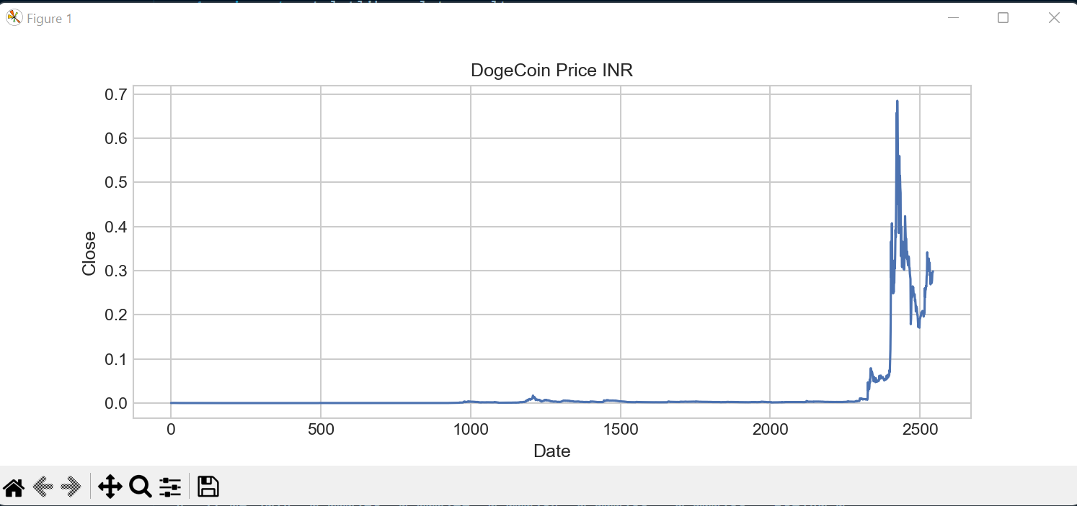

**SYNOPSIS**

As there is an increased use of crypto in the recent years, people started to adapt the use for crypto. This increased use in the market has made crypto highly volatile. This project might help small scale data analyst and large scale data analyst to predict the price of crypto that may result in increased value in the future

With the evolution of the information industry and extensive research in the field of AI in the past two decades, businesses have started to explore the ways to automate various activities using state of the art Machine Learning algorithms and Deep Neural Networks. Many IT giants and start-ups have already taken a big leap in this field and have dedicated teams and resources for research and development of cutting edge AI applications.

Online retail platforms today are extensively driven by AI-powered algorithms and applications. Activities ranging from inventory management and quality checking at the warehouse to product recommendation and sales demographics on the project, all employ machine learning at various scales.

The objective of this project is to predict the change in price of the crypto currency and to display in the user interface so that the data analyst as well as normal users can make use of the data to buy and invest or to make business decisions in crypto tokens such as Dogecoin, Ape coin, Solana etc….

Here we use AutoTS (Automatic time series) machine learning algorithm to predict the change in prices. The AutoTS python library separates the data into training and testing automatically and the output values are stored in model_results variable which can be accessed by the data analyst to make business decisions. AutoTS is a very powerful automated machine learning algorithm which is used to predict values with higher accuracy from time to time.



Sanjay K (20MSS040), Third year M.Sc. Software systems

Batch (2020-2025) in PSG college of Arts & science, Coimbatore.